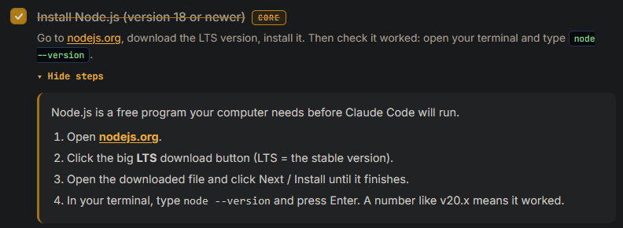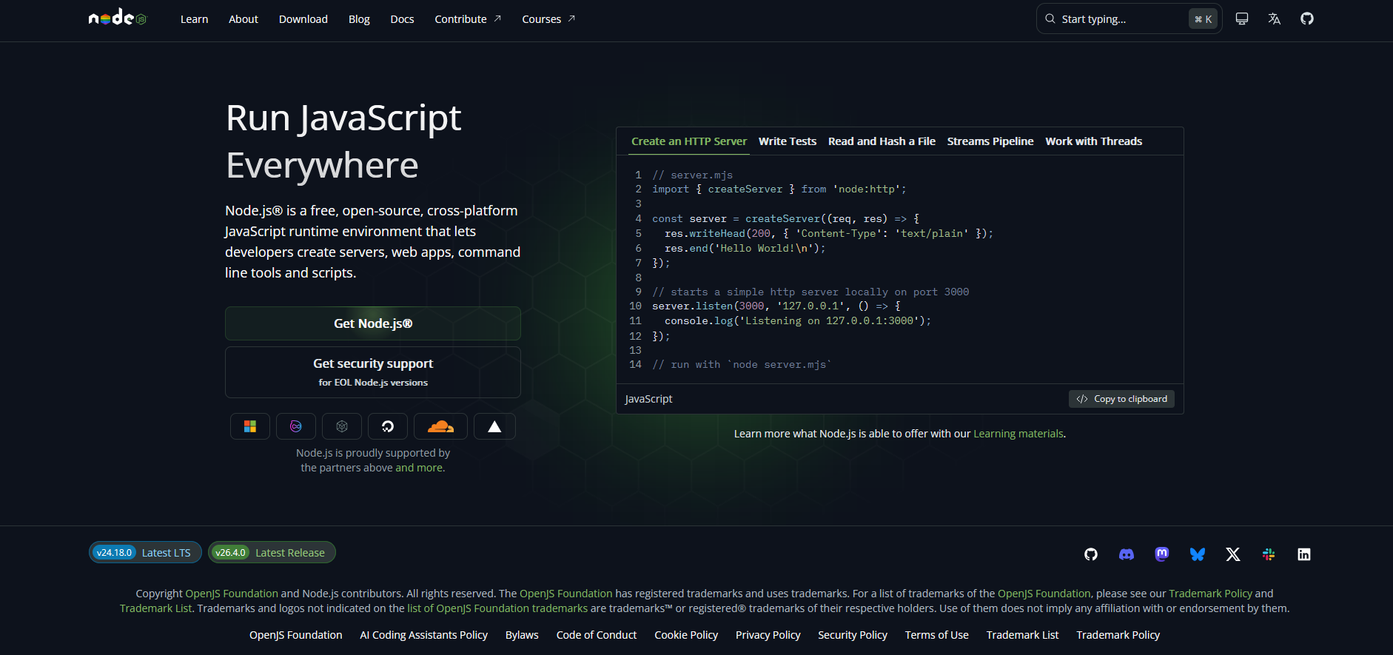
Step 2 would read better as “Click the Get Node.Js button and follow the instructions to install the correct installation for the OS you’re using” or similar

